TITLE IN ENGLISH
(Times New Roman 12 pt, BOLD UPPERCASE except species name which should be written as usual e.g. Escherichia coli)
Author1,¹ Author2,² Author3^{3,}*
(Times New Roman 12 pt; underline the presenter’s name but not the comma and number and place * (not superscripted) after corresponding author’s name; use (full) Firstname Lastname format e.g. Tirayut Vilaivan – do not abbreviate initials.)
¹Affiliation of 1st author
(Times New Roman 12 pt, include country name, without fullstop)
²Affiliation of 2nd author
(No spacing before and after paragraph)
³Affiliation of 3rd author
(Combine the affiliations that are shared by more than one authors, Do not use number if all authors share the same affiliation.)
*e-mail:
e-mail address of the corresponding author (leave a blank space after :)
(Leave a blank line between e-mail and abstract.)
Abstract:
Use Times New Roman 12 pt, symbols should be inserted by using menu Insert>Symbols (Font: Symbol 12 pt). The text should be fully justified.
(Leave a blank line before and after Figures.)
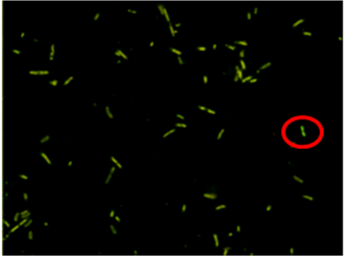 | 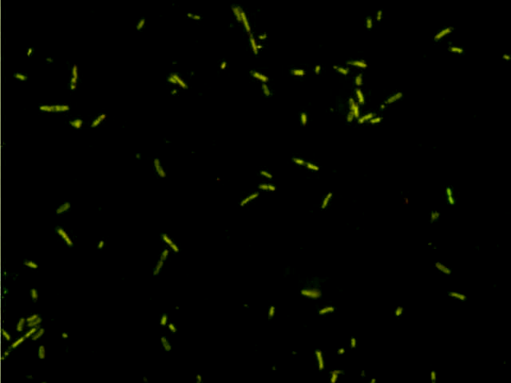
Figure 1.
Examples of acceptable figure (left) and unacceptable figure (right)
Click and drag the red circles to compare the difference.
(Leave a blank line before and after Figures.)

References, acknowledgements and keywords should not be included as they will not be incorporated into the abstract book!

Details of template setting:
Page Layout: A4, portrait, 1" margins
Font: Times New Roman 12 pt, for Symbols use menu Insert>Symbol (Font: Symbol 12 pt)
Paragraph Style: Single line spacing and fully justified, except for title, authors and affiliations, which should be left-justified. Spacing before and after paragraphs should be set to 0 pt (i.e. no spacing between paragraphs). Do not use blank line to separate paragraphs. Indentation should be made manually by using Tab. Autoindent and autonumber features in Word should be disabled.
Other: The maximum length of abstract is ONE page. Delete all the “red” text before saving. Save the file in Word 2003-2007 document (.doc) / Word document (.docx) format.

